Lab 3
Serial WAN Communications
Objective:
The purpose of this lab is for the student to understand, create and implement serial connections. Students will also utilize IOS commands to explore and configure serial connections on network routers.
Diagram:
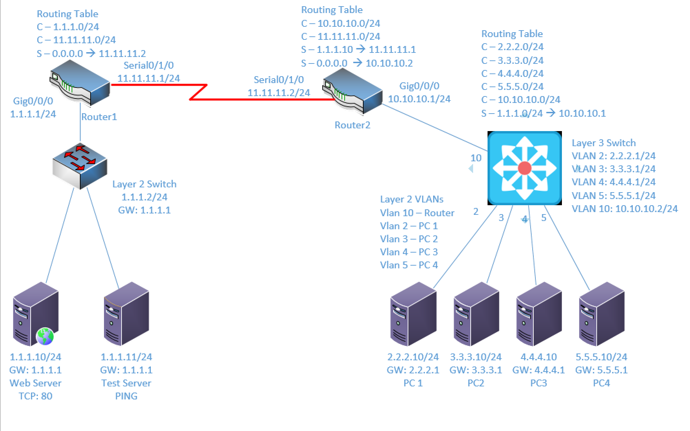
Components:
6 – PC’s with an Ethernet NIC
1 – 3650 Layer 3 Switch
1 – 2960 Layer 2 Switches
2 – 4321 Routers (with NIM 2T WAN card)

Useful commands for this lab:
show ip route – view routing table
show vlan – View vlan table and port assignments
show ip interface brief – view status of layer 3 ports
show access-lists – view access lists and hit counters
show ip nat translations – view NAT table
Add IP address to Serial Interface (same as Ethernet)
interface Serial0/1/0
ip address 5.5.5.1 255.255.255.0
no shutdown

Enable routing on Layer 3 switch
ip routing

PPP – Clock rate only on DCE side.
interface serial0/1/0
encapsulation ppp
clock rate 1536000
ip address 1.1.1.1 255.255.255.0
no shutdown

Add CHAP to PPP
Router(config)#hostname R1
R1(config)#username R2 password netcom
R1(config)#interface serial0/1/0
R1(config-if)#encapsulation PPP
R1(config-if)#ppp authentication chap

Router(config)#hostname R2
R2(config)#username R1 password netcom
R2(config)#interface serial0/1/0
R2(config-if)#encapsulation ppp
R2(config-if)#ppp authentication chap

Procedure:
- This lab will have to be done in Packet Tracer. The new lab gear does not have serial ports. Connect all PC’s together and put their static IP addresses, subnet masks and gateways on them. Create a new Packet Tracer File. Add the components listed above. It’s important to use the same models because I’ve tested them with this lab.

- Click on the Router1. Click the “physical” tab. Click the power button to power the router off. Click and drag the “NIM-2T” over to the blank modular slot on the right. Power the router back on. See second figure for final state.
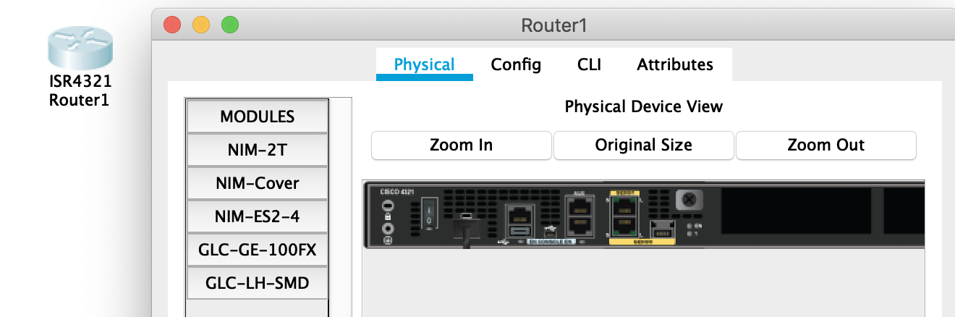
Figure 1: Router without Serial Card

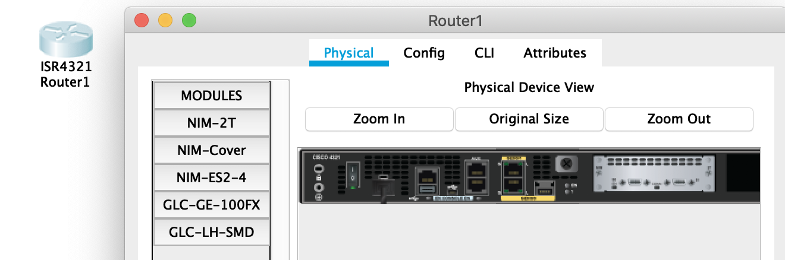
Figure 2: Router with Serial Card

- Power the router on by clicking the power button again.
- Follow the same procedure to add the Serial card to Router 2.
- Use the diagram above to label the Layer 3 switches VLAN IP addresses and ports below
Layer 3 Switch
VLAN | IP | Switch port
2 | 2.2.2.1/24 | 2
3 | 3.3.3.1/24 | 3
4 | 4.4.4.1/24 | 4
5 | 5.5.5.1/24 | 5
10 | 10.10.10.2/24 | 24

- Use the diagram above Label the routing tables for the Layer 3 switch and routers below.
Router 1 | Router 2 | Layer 3 Switch
C 1.1.1.0/24 | S 1.1.1.0/24–>11.11.11.1 | S 1.1.1.0/24–>10.10.10.1
C 11.11.11.0/24 | C 10.10.10.0/24 | C 2.2.2.0/24
S 0.0.0.0/0 –>11.11.11.2 | C 11.11.11.0/24 | C 3.3.3.0/24
 | S 0.0.0.0/0 –>10.10.10.2 | C 4.4.4.0/24
 |  | C 5.5.5.0/24
 |  | C 10.10.10.0/24

- Place the switch ports into the proper vlans. Configure all of the switches vlan IP addresses.
  - Example: Make sure to adjust the port number, vlan number and IP address to match your task. This is just an example.
interface Gigabitethernet 1/0/1
switchport mode access
switchport access vlan 2
no shutdown
interface vlan 2
ip address 2.2.2.1 255.255.255.0
no shutdown

- Enable routing on the Layer 3 switch

- View the routing table on the Layer 3 switch.

- Verify that the PC’s on the switch can ping each other

- Configure the IP addresses on the GigabitEthernet0/0/0 router interfaces and turn the interfaces on. Remember the interfaces are shutdown when a router is powered on.

- Plug the DCE cable into the router with the 10.10.10.0/24 and 11.11.11.0/24 networks. Remember from the lecture than the DCE side of the cable is configured with the clock source. Do this by clicking the lightning bolt icon in Packet Tracer to open the cables menu, click the red cable with the clock, click Router 2, select one of the serial interfaces, click router 1 and finally select one of the serial interfaces. Should look similar to Figure 3 at this point:
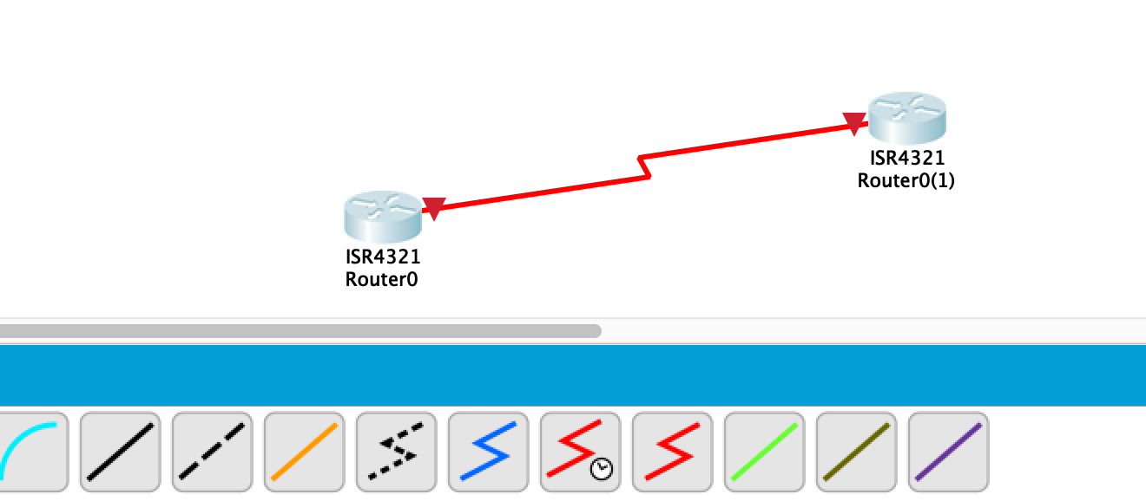
Figure 3: Add serial cable

- Configure the serial0/0 interfaces on both routers for ppp encapsulation.

  - What command did you enter?
Encapsulation ppp

- Make the serial0/0 interface clock rate 56k

  - What command did you enter?
Clock rate 56000

  - Which router did you put the clock rate command on (DCE/DTE)? Router 2
How do you know which router is the DCE? Look at the icon in Packet Tracer.
I know because I used the DCE cable with the clock, clicked Router 2 first, and was able to set the clock rate on Router 2. When I tried to set the clock rate on Router 1, it said “This command applies only to DCE interfaces”

- Place IP addresses on the router serial0/1/0 interfaces and turn them on. Remember the routers interfaces are shut down by default. Once the IP addresses are configured and the ports are turned on, the red lights should turn green.

  - What command did you enter?
Int serial0/1/0
Ip address 11.11.11.1 255.255.255.0
No shutdown

- Place the proper static routes on the routers and switch. Use the diagram at the beginning for reference.
  - What route did you enter on the switch?
Ip route 1.1.1.0 255.255.255.0 10.10.10.1

  - What route did you enter on router 1?
Ip route 0.0.0.0 0.0.0.0 11.11.11.2

  - What routes did you enter on router 2?
Ip route 1.1.1.0 255.255.255.0 11.11.11.1
Ip route 0.0.0.0 0.0.0.0 10.10.10.2

- View the routing table on both routers and make sure the routing table is similar to the diagram at the beginning of the lab.

- Can every PC ping each other? Yes!

- Place hostnames on the routers of R1 and R2. What commands did you use?
Hostname R1
Hostname R2

- Place a username of R1 with a password of netcom on R2. The username and password are case sensitive. Make sure you match the case between the username and router hostname.

  - What command did you enter?
Username R1 password netcom

- Place a username of R2 with a password of netcom on R1

  - What command did you enter?
Username R2 password netcom

- Add chap authentication to on Router1

  - What command did you enter?
PPP authentication CHAP

  - Can every PC ping each other?
No
  - Why?
CHAP authentication was only enabled on one router, so the PCs can’t reach one another because one router requires authentication that the other is not set up for yet.
- Add chap authentication to the other router

  - What command did you enter?
PPP authentication CHAP

  - Can every PC ping each other?
Yes
  - Why?
Because CHAP is now enabled on both routers so they can pass packets between themselves with proper authentication.

- Create the lab diagram below (PCs, router and switch connections) in Packet Tracer or Visio. Label the IP addresses, subnet masks, and gateways used by each device. Label the routing tables next to the switch and router and the switches vlan IP addresses and port vlan information. Label the WAN connection.

